PRESS-INFORMATION

FOR IMMEDIATE RELEASE

Contact: Dr. Rolf Schwen
Tel. +49-89-27818601

Arrived in Future
NEOPLAN Busses Starliner and Cityliner equipped with PREMIUM-SEAL repair-sets

Besigheim/ Salzgitter/ Munich 14.11.2006: Looking at the new NEOPLAN busses Starliner and Cityliner you feel like being transferred into the automotive future. You can see landscapes passing-by while you are enjoying the maximum convenience on board of the busses. In contradiction to that: How stone-aged may seem the opportunity of a puncture? –As the first bus-manufacturer worldwide NEOPLAN has been replacing the spare wheel of the Starliner with PREMIUM-SEAL Repair since one year. As result of the good experience being made a tyre-puncture shall not cause long stops in international bus-tours: The new Cityliner - being introduced at the international show for commercial vehicles IAA in Hanover- is also delivered with PREMIUM-SEAL-Repair as standard.

The pleasure of a trip with busses equipped with a spare-wheel sometimes is ending with a tyre-puncture. An unpleasant and irritating event for the driver as well as for the passengers. The bus driver has to pull out the bulky spare wheel – weighing 100 kg - unscrew and the bolts and tighten them again. This action comes with a lot of risks, especially if the punctured tyre is at the busy road-side. According to a statement of the Austrian automobile association ÖAMTC over 400 people die during tyre-puncture-stops in the USA each year. In Germany more than 1300 accidents are caused by the same reason per annum.

Normally the bus-driver decides on a secure alternative and calls a road-assist-service. But it may take some time until the service is on-site. In the meantime the passengers are in the open or waiting annoyed in the bus.

By now this will be changed: In the case of a puncture the driver takes the sealant-bottle, fills it through the valve stem of the punctured tyre, reinstalls the recommended tyre pressure with the on-board compressor and continues the trip after ten minutes. PREMIUM-SEAL Repair grants safety as well by a simple and efficient filling as by a prompt and durable sealing. The Swiss organisation for consumer protection bfu declares that repair sets are safer than the change of a wheel, because they are considerably reducing the dangerous puncture stop. bfu is recommending PREMIUM-SEAL Repair.

According to a DEKRA-report there are no problems in cleaning and if necessary repairing the treated tyre. The Bavarian State Office for Environmental Protection has confirmed that the product is environment-friendly and that remains can be disposed of in the sewage system.

The NEOPLAN engineers have convinced themselves of the efficiency of PREMIUM-SEAL-Repair. For 1.5 years the severe inspection included puncture-tests with objects up to 12 mm in diameter and driving distances of more than thousand kilometres. Heiko Marquardt, manager of the NEOPLAN test department declares: “We discovered more than a puncture repair-set with PREMIUM-SEAL Repair. The system makes sure that our bus entrepreneurs can offer even more safety and comfort as well to their customers as to their drivers. This product exceeded all our expectations.”

Further advantages and the superiority in comparison to other temporary repair-products have convinced NEOPLAN to use PREMIUM-SEAL Repair as a standard: There is more capacity for an additional passenger because the space and the weight of the spare-wheel is saved. Up to 0.3% less fuel-consumption. The maintenance of the spare wheel and its exchange do not arise. Bus-drivers can keep their travel-agenda although they had a tyre-puncture. These advantages can not be disregarded. Companies can even use these advantages in their existing fleet and up-date a bus with the repair-set. PREMIUM-SEAL Repair is available at any good tyre dealer.

About PREMIUM-SEAL:
Innovation and service in the motor-industry are claim and motivation for Premium Vertriebs GmbH. Today the company is represented in more than 30 countries. Innovation means to look at a problem as a challenge and to handle it with simple and innovative means. Service is the absolute will that customers are satisfied. With this guideline PREMIUM-SEAL has become standard supplier for companies like DaimlerChrysler, NEOPLAN etc. Famous trade organisations such as BOSCH, Point-S, TOP SERVICE TEAM and others have decided to distribute this product. An area-wide supply is realized in Germany and other countries as well. The product gains importance as it contains no latex. So the problems which are well-known in the tyre-industry are avoided.

Press-Contact
Premium-Vertriebs GmbH NEOMAN Bus GmbH
Dr. Rolf Schwen Thorsten Wagner
schwen@premiumseal.com Thorsten.Wagner@neoman.de
Tel. +49-89-27818601 Tel. +49-5341-28-2268
Fax. +49-89-27818602

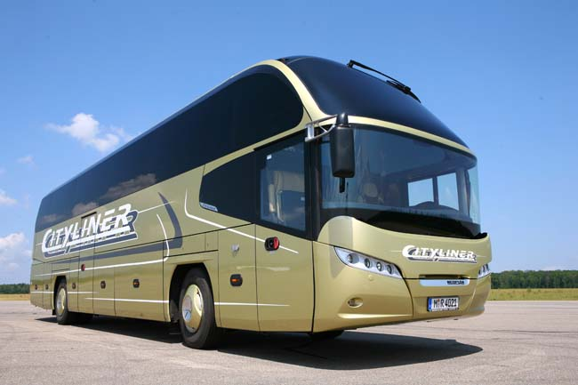
Photos of the Cityliner and the Starliner can be received on request or downloaded on our web-page.
http://www.premiumseal.com/
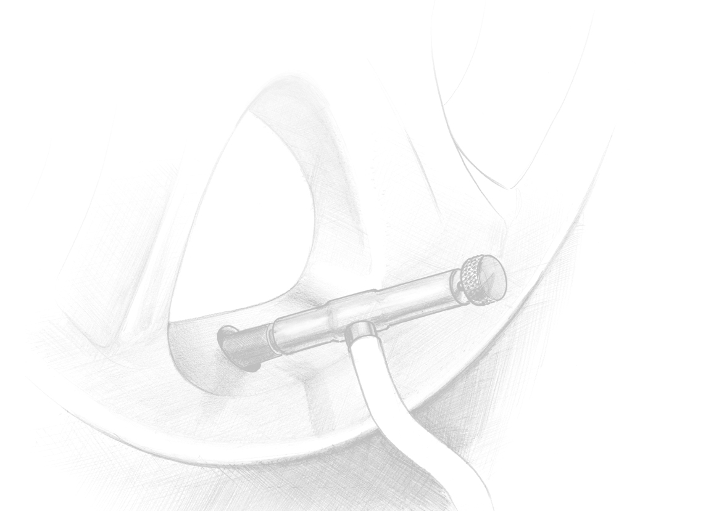
Deutsche Bank Ludwigsburg VR-Bank Stromberg Neckar eG Geschäftsführer: Regina Plep
Konto 022 9005 · BLZ 604 700 82 Konto 404 429 009 · BLZ 604 914 30 Handelsregister: Vaihingen/Enz HRB 2130-Bes
IBAN DE14 6047 0082 0022 9005 00 IBAN DE86 6049 1430 0404 4290 09 UST.-Id-Nr. DE813485144
BIC DEUTDESS604 BIC GENODES1VBB Steuer-Nr. 55081/06678

